
CASA of the Continental Divide
Social Media Brand Guide
2023

CASA of the Continental Divide Brand…………………………………………………………… Page 2
Brand Positioning…………………………………………………………………………………………………. Page 2
Brand Personality…………………………………………………………………………………………………. Page 3
Visual Style Instructions……………………………………………………………………………………… Page 4
Logos…………………………………………………………………………………………………………… Page 4
Colors………………………………………………………………………………………………………….. Page 4
Fonts……………………………………………………………………………………………………………. Page 5
Post Frame………………………….................................................................... Page 6

The CASA of the Continental Divide Brand

Brand Positioning

Vision
Our vision is to see all children in Colorado’s 5th Judicial District thriving.

Mission
CASA of the Continental Divide guides volunteer advocates who ensure a child’s safety, best interest and well-being are at the forefront of legal proceedings.

Goal
Our goal is to be appointed for and have volunteers serving 100% of child welfare and truancy cases throughout the district.

CASA of the Continental Divide Brand Personality
Our personality already shines through in all our posts and messaging, but these are adjectives that can be used to describe CASACD’s brand’s tone, and what will continue to help us reach our audience in the most authentic way. (Please feel free to add adjectives that you think describe our brand, too!)

Passionate
Our passion for improving the lives of children and families in Colorado’s 5th Judicial District is apparent in our word choice, our volunteer recruitment posts, and our enthusiasm for what we do. We always bring our “asks” back to our mission.

Reliable
Our organization is reliable. We are always responding to comments, questions and messages from our followers and supporters. We are also consistent in our posting frequency, our messaging, and tone. People in the community can rely on us to be helpful, trustworthy, and easy to reach.

Friendly
Our online presence is friendly! Just like we are reliable and passionate in what we do, we communicate in a way that is welcoming to all. We are an inclusive organization and that is reflected in the way we phrase our communications through newsletters, social media posts, and all interactions.

Logo

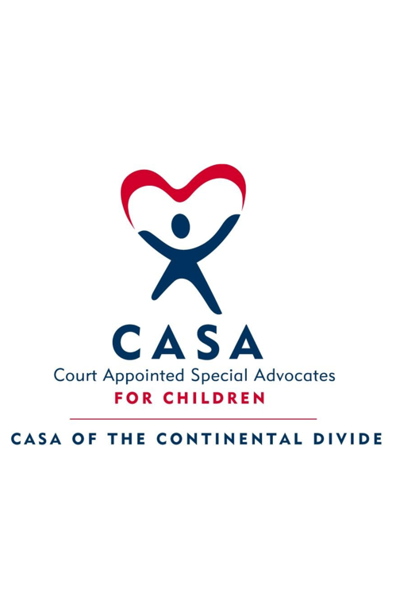 | This is CASACD’s only logo. It can be used in the corner of social media posts, email signatures, posters, flyers, letters, etc.
 | Per national CASA guidelines, we are not able to alter the CASACD logo in any way. This includes distortion, colors, or adding any phrasing to it.

Colors


#385072 #da291c #4ec1e0

Our posts are not restricted to these colors, but when they are used these are the specific numbers on Canva used to create them.

Font family for social media posts:

Montserrat

Examples:

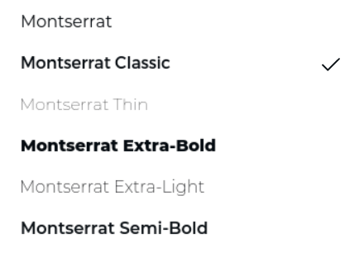

Post Frames

These frames will be used on every social media post across Instagram/Facebook to create a cohesive look on our pages, and ensure our logo is visible on every post.



The white gradient can fade to the color of the background of the post; it does not need to be the CASA red/blue, but these are examples of the white fading into the color of the background.

This can be done on Canva using this frame template!

Examples of social media posts using Montserrat & Frame with logo:

